Dsa Lab Assignment

Suresh Kumar

Cs231160

3d

Q1  
import java.util.Scanner;

public class Q1Quiz {

public static void main(String[] args) {

int[] arr = new int[10];

// arr[0] = 20;

// arr[1] = 30;

// arr[2] = 40;

// arr[3] = 50;

// arr[4] = 60;

Scanner sc = new Scanner(System.in);

int size = 0;

int n = sc.nextInt();

// int key = sc.nextInt();

for (int i = 0; i< n; i++){

arr[i] = sc.nextInt();

size++;

}

for (int i = 0; i<n; i++){

System.out.print(arr[i] +" ");

}

System.out.println("Enter element you index at wahich you want to edit value");

int indx = sc.nextInt();

System.out.println("Enter the value you want to insert");

int val = sc.nextInt();

for (int i = 0; i<n; i++){

if (i==indx){

arr[i] = val;

}

}

for (int i = 0; i<n; i++){

System.out.print(arr[i] +" ");

}

System.out.println("Enter element index you want to delete");

indx = sc.nextInt();

for (int i = indx; i<n; i++){

arr[i] = arr[i+1];

}

n = n-1;

for (int i = 0; i<n; i++){

System.out.print(arr[i] +" ");

}

}

}

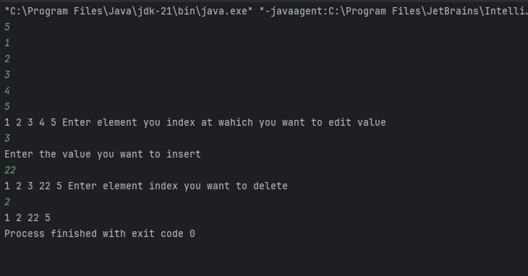

Q2

public class ReverseArray {

public static void main(String[] args){

int[] arr = {1,2,3,4,5};

int n = arr.length;

System.out.println("Before Reverse");

for (int i = 0; i<n; i++){

System.out.println(arr[i]);

}

int[] arr2 = new int[n];

for (int i=0; i<n; i++){

arr2[i] = arr[n-i-1];

}

for (int i =0; i<n; i++){

arr[i] = arr2[i];

}

System.out.println("After Reverse");

for (int i = 0; i<n; i++){

System.out.println(arr[i]);

}

}

}

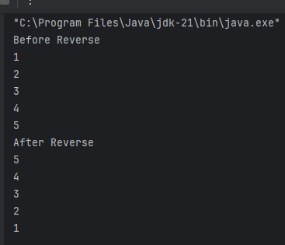\

Q3

public class FindMinValueOfArray {

public static void main(String[] args) {

int[] myArray = {22,33,44,55,1,4,2};

int n = myArray[0];

for (int i = 0; i<myArray.length; i++){

if (myArray[i]<n){

n = myArray[i];

}

}

System.out.println("The min value is "+n);

}

}

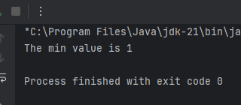

Q4

public class SecondMaxValue {

public static void main(String[] args) {

int[] myArray = {5,3,8,2,1};

int max = -1;

int secMax = -1;

for (int i = 0; i<myArray.length; i++){

if (myArray[i]>max){

secMax = max;

max = myArray[i];

}

else if (myArray[i] > secMax && myArray[i] <max){

secMax = max;

}

}

for (int i = 0; i<myArray.length; i++){

System.out.print(myArray[i] +" ");

}

System.out.println();

System.out.print("Second max value is :");

System.out.println(secMax);

}

}

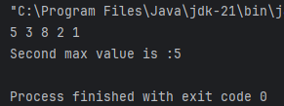

Q5

public class MoveZeros {

public static void main(String[] args) {

int[] myArray = {1,2,3,0, 4, 0, 5};

int index = 0;

System.out.println("Original array");

for (int i = 0; i<myArray.length; i++){

System.out.print(myArray[i]+" ");

}

System.out.println();

for (int i =0; i< myArray.length; i++){

if (myArray[i]!=0){

myArray[index] = myArray[i];

index++;

}

}

while (index< myArray.length){

myArray[index] = 0;

index++;

}

for (int i = 0; i< myArray.length; i++){

System.out.print(myArray[i]+" ");

}

}

}

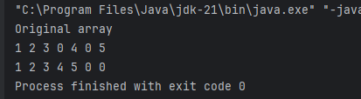

Q6

import java.util.Arrays;

public class ArrayResize {

public static void main(String[] args) {

int[] myArray = {1,2,3,4,5};

int newsize = 8;

System.out.println("Original Array");

for (int i= 0; i<myArray.length; i++){

System.out.print(myArray[i]+" ");

}

System.out.println();

System.out.println("Resized array");

int[] resizeArray = Arrays.copyOf(myArray, newsize);

for (int i = 0; i< resizeArray.length; i++){

System.out.print(resizeArray[i]+" ");

}

}

}

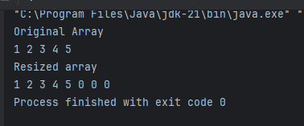

Q7

public class FindMissingNumber {

public void findMissing(int arr[], int n){

int originalSum = (n\*(n+1))/2;

int arraySum = 0;

for (int i = 0; i<n-1; i++){

arraySum = arraySum + arr[i];

}

int missingNum = originalSum-arraySum;

System.out.println("The missing number is: "+missingNum);

}

public static void main(String[] args) {

FindMissingNumber find = new FindMissingNumber();

int[] arr = {1,2,3,5};

int n = 5;

System.out.println("Original Array");

for (int i = 0; i<arr.length; i++){

System.out.print(arr[i]+" ");

}

System.out.println();

find.findMissing(arr, n);

}

}

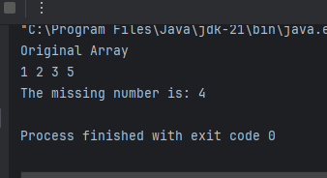

Q8

import java.util.Scanner;

public class Palindrome {

public boolean isPlindrome(String text){

String reverse = "";

for (int i = text.length()-1; i>=0; i--){

reverse = reverse + text.charAt(i);

}

if (text.equals(reverse)){

return true;

}

else {

return false;

}

}

public static void main(String[] args) {

Palindrome check = new Palindrome();

Scanner sc = new Scanner(System.in);

System.out.println("Enter a n text to check that it is palindrome or not");

String text = sc.nextLine();

boolean out = check.isPlindrome(text);

System.out.println(out);

}

}

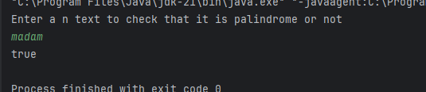

Q9

import java.util.Scanner;

public class InDelSrch {

public int Search(int[] arr, int key){

for (int i = 0; i< arr.length; i++){

if (arr[i] == key){

return i;

}

}

return -1;

}

public int insert(int[] arr,int n, int key){

int i = 0;

for (i = n-1 ;(i>=0 && arr[i] > key); i--){

arr[i+1] = arr[i];

}

arr[i+1] = key;

return n + 1;

}

public int delete(int[] arr, int n ,int key){

int pos = Search(arr, key);

if (pos == -1){

System.out.println("No element found");

}

for (int i = pos; i<n-1; i++){

arr[i] = arr[i+1];

}

return n-1;

}

public static void main(String[] args) {

InDelSrch obj = new InDelSrch();

int[] arr = new int[10];

arr[0] = 20;

arr[1] = 30;

arr[2] = 40;

arr[3] = 50;

arr[4] = 60;

int n = 5;

int key = 0;

System.out.println("THe original array");

for (int i = 0; i<n; i++){

System.out.print(arr[i]+" ");

}

System.out.println();

Scanner sc = new Scanner(System.in);

System.out.println("ENter number to find the position");

key = sc.nextInt();

int val = obj.Search(arr, key);

System.out.println("Element found at the position: "+val);

System.out.println("Enter the value you want to store");

key = sc.nextInt();

n = obj.insert(arr, n, key);

for (int i = 0; i<n; i++){

System.out.print(arr[i]+" ");

}

System.out.println();

System.out.println("Enter a value you want to delete");

key = sc.nextInt();

n = obj.delete(arr, n, key);

for (int i = 0; i<n; i++){

System.out.print(arr[i]+" ");

}

}

}

